Name: ...............................................
Top 100 French words used in AQA Listening and Reading – Foundation Level only
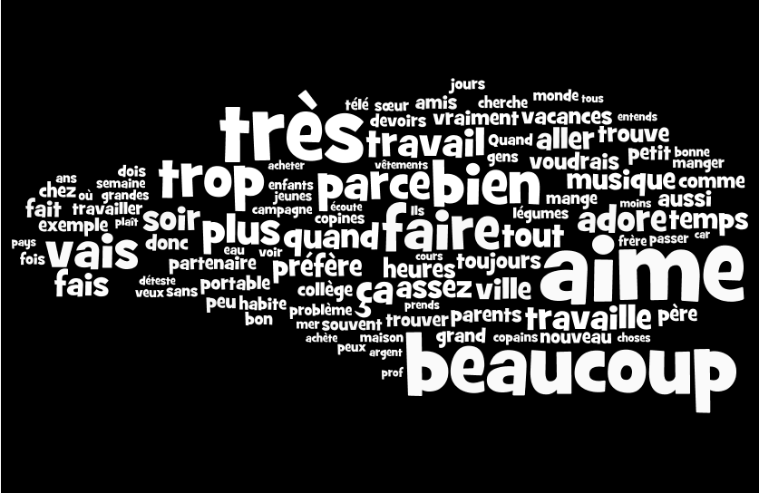
How many do you know? green = definitely, amber= think so, red = no idea!

